**Anonymous functions and arrow functions**

**1-anonymous function:**

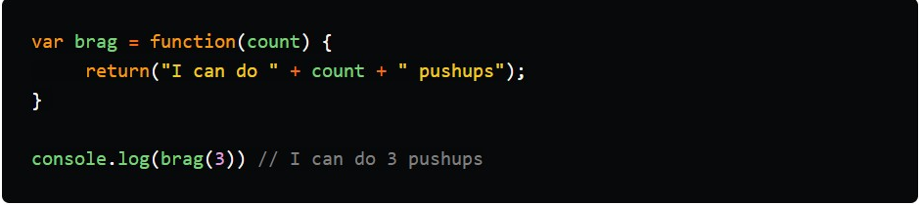

**2-arrow function:**

